ORCiD
To register for an ORCiD number
Log into Elements.
On your Home Page go down to My Data Sources and click on ORCiD configure.
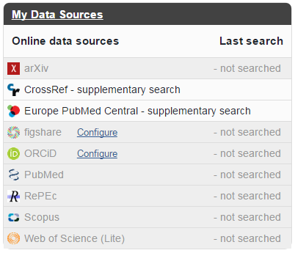
You will be taken through to the ORCiD website to register. Click on Register
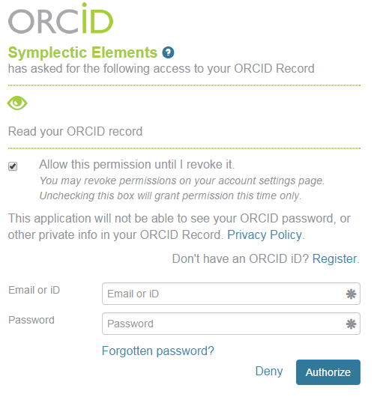
Complete the required information fields and click on the Authorise Button
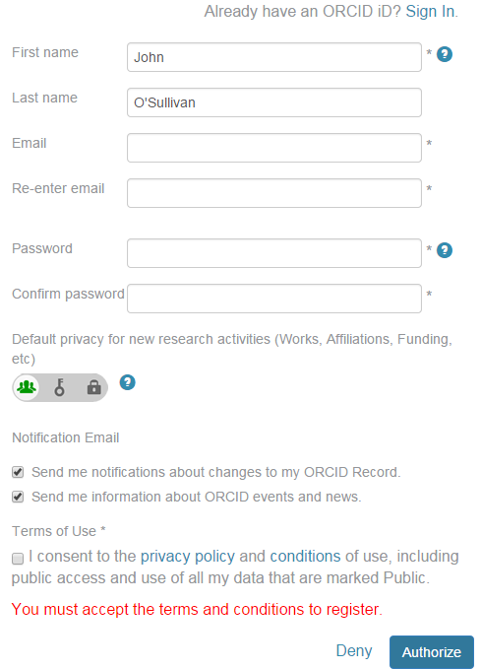
You will be returned to Elements and an email verification message will be sent to your email address.
- Please log into Elements again to connect the two systems.
- Complete the verification process in Outlook by clicking on the link provided by ORCiD in the email.

Accessing ORCiD via Elements
On your Home Page go down to My Search Settings and open.
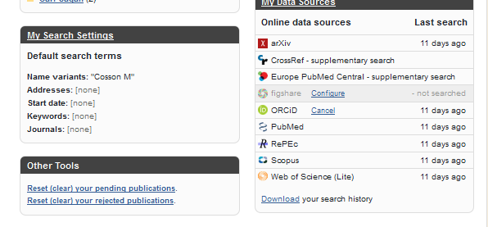
Go to the bottom table of Data Sources and click on your ORCiD number.
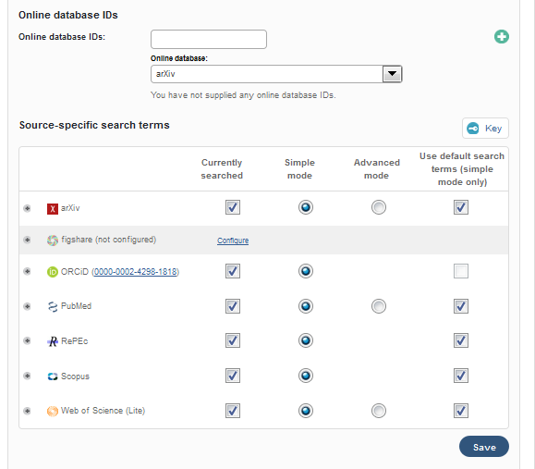
A new tab will open and take you to the ORCiD Website
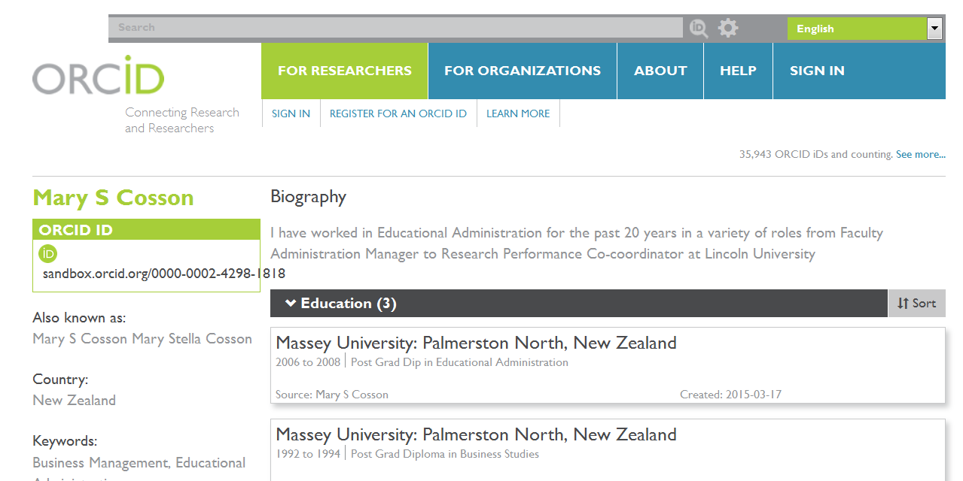

To Add or Edit any stored information, click on SIGN IN and log into ORCiD
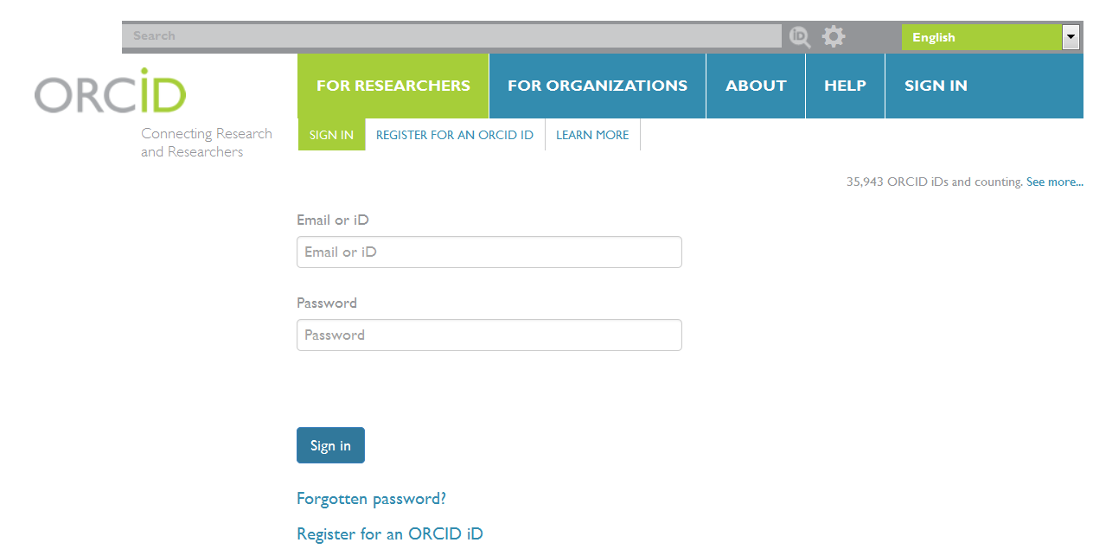
You can use your LU Email address or your 16 digital ORCiD number.

Once you have signed in the privacy settings and add buttons will appear.
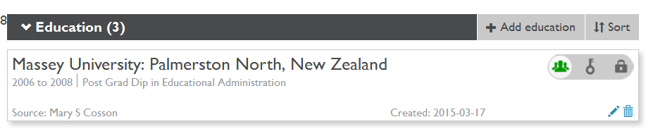

Overview information – left hand side of the home page.
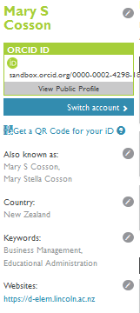
You can add more information to these fields by clicking on the icon and saving the changes

Account settings
You can manage your account and privacy options from the Accounts setting tab.

You can change your Email, Password, privacy preferences, security questions and trusted organisations/individuals list settings.
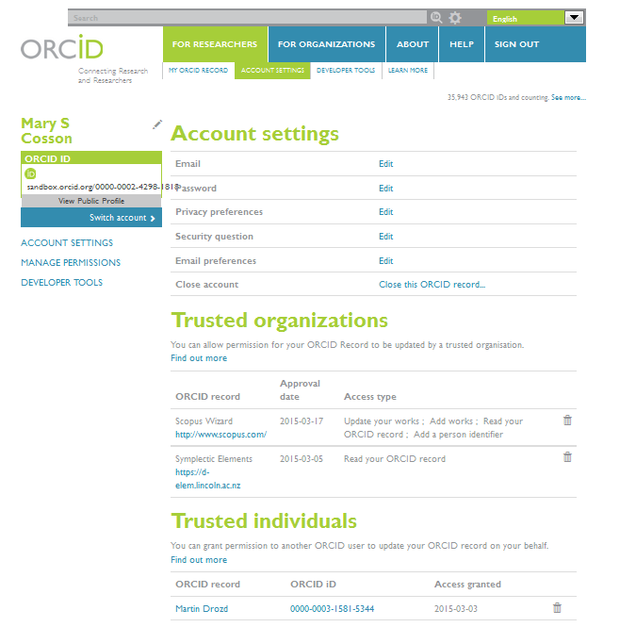
Email Settings
You can add more one email addresses and choose a Primary Email address.
Password
You can change your password at any time.

Privacy preferences
You can set your privacy setting for each section of your ORCiD profile
Public – Will be seen by anyone who searches your name in ORCiD
Limited – Will only be seen by Trusted Individuals
Private – Will not be seen by anyone. Only available to you.

Security Question
You can set a security question which will be used if you forget your password.

Email Preferences
Choose how much information you receive from ORCiD.

Trusted Organisations
As you connect to such organisational systems as Elements and Scopus, the organisation will become a Trusted Organisation in your list.
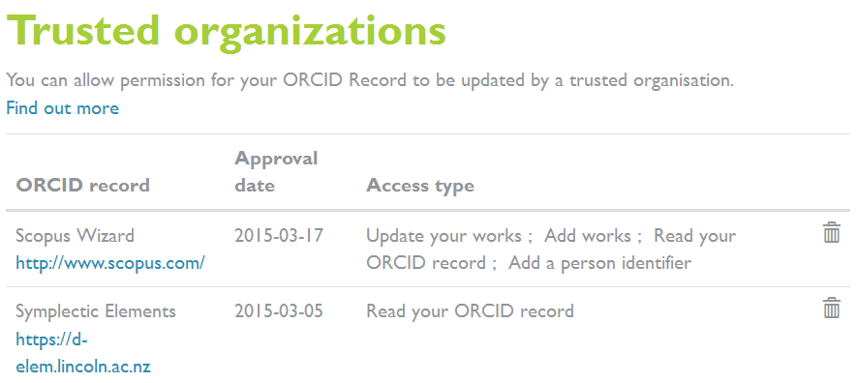

Trusted Individuals
If you want to grant permission to another ORCiD user to update your ORCiD record on your behalf
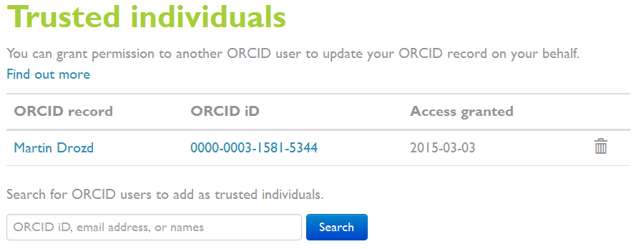
Search on their name and Add them to your Trust list.

Create a Biography
Click on the icon to develop your Biography statement.
Once completed please save using the button.

Create your Education list
Click on the button and the + Add manually button

Complete the table and click on the Add to List button to save.
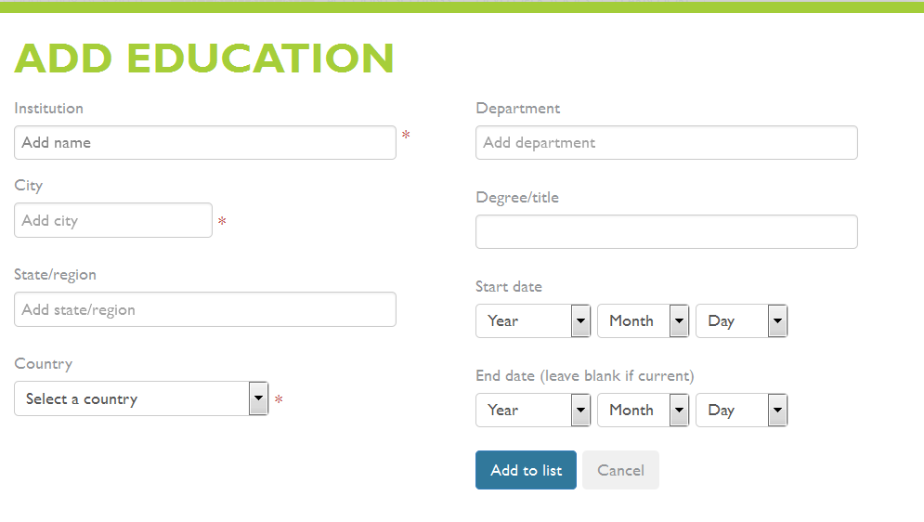

To create your Employment list
Click on the button and the + Add manually button
Complete the table and click on the Add to List button to save.
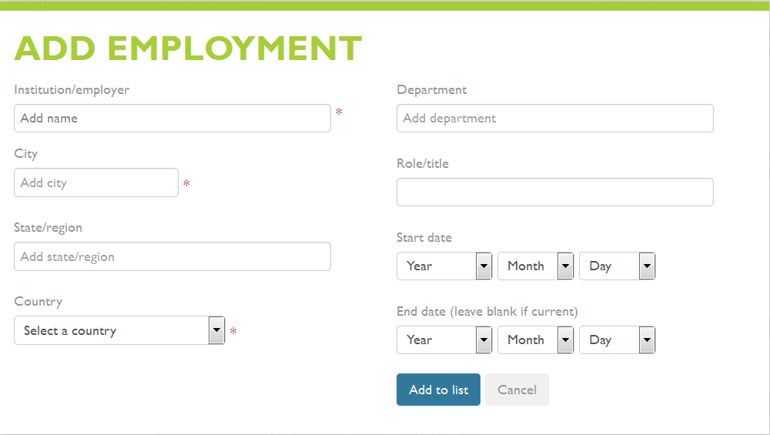

To add to your Funding list
Click on the button and the + Add manually button
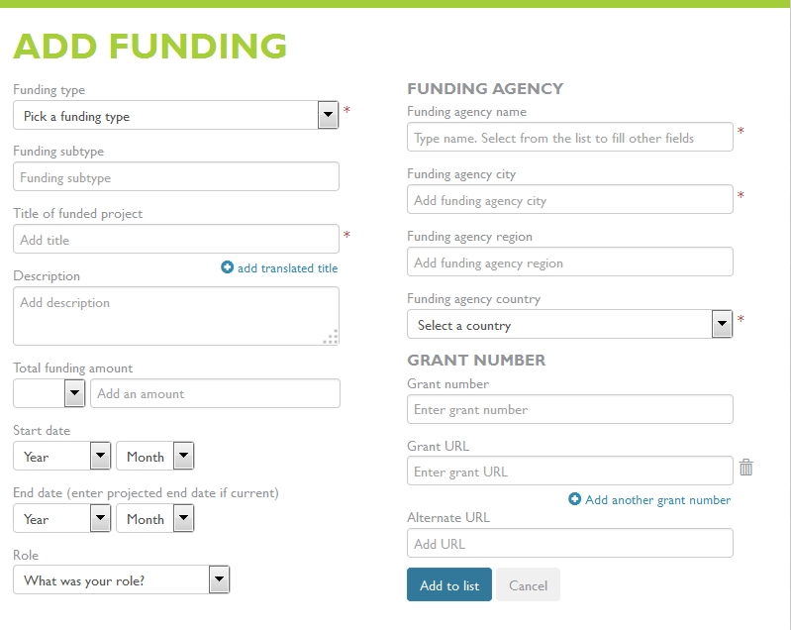
Complete the table and click on the Add to List button to save.

How to fill your Publication List
You have the ability to source your publications from data sources such as Scopus and ResearcherID by linking on the Search and Link option.
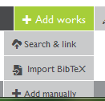
Search and Link will take you through to the list of data sources that ORCiD currently has access to. This list includes CrossRef, DataCite, ResearchID and Scopus Wizard.

Click on the Data source you wish to use and follow the instructions given.
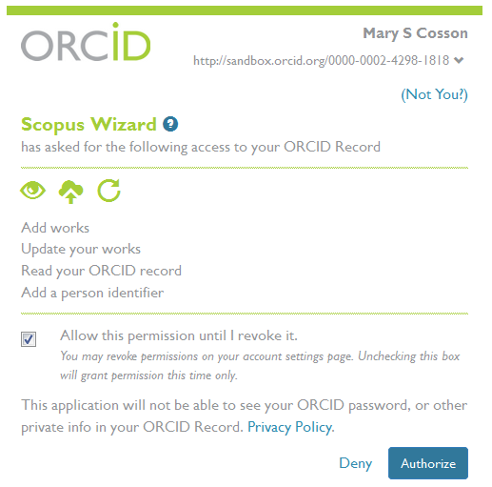
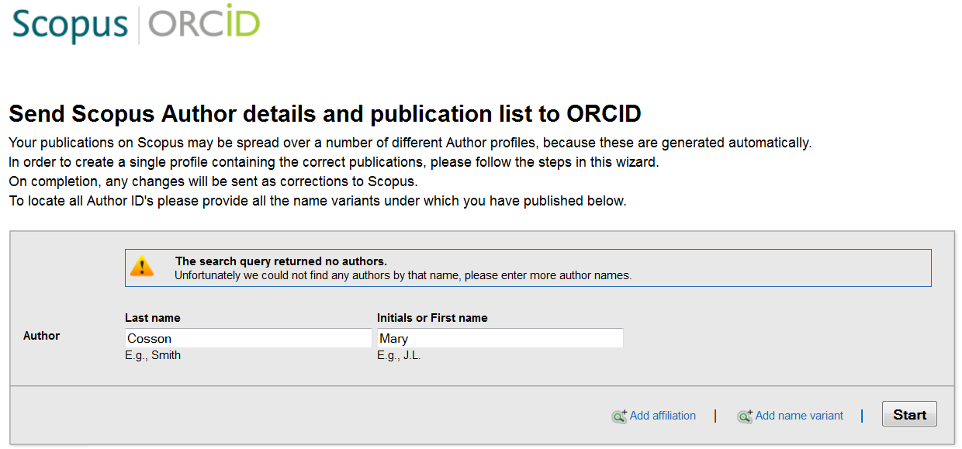

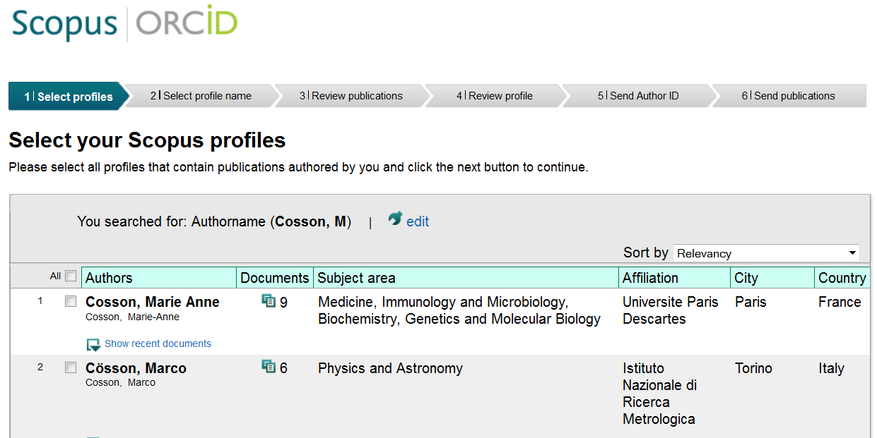
Remember to click on the next button at the bottom of the screen to go onto the next stage.
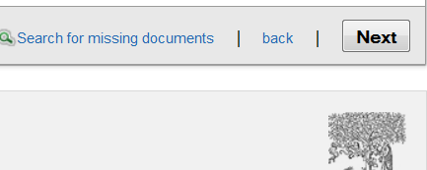

Further Help
If you require any further help, click on the HELP tab

To sign out
Click on Sign out and you will be taken to the sign in area of your ORCiD profile. If you want to return to Elements, click on the Elements tab in the menu bar.

