Leganto Tips

In Learn

Creating a link in Akoraka | Learn
- Go to your course page and turn editing on.
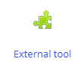
- In the first section of your course, select ‘Add an activity or resource’.
- Choose ‘External tool’.

- Give the link a name and choose Leganto from the ‘Preconfigured tool’ drop down box.
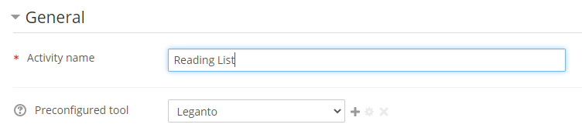
- Save and return to course.

Linking a specific section or reading from Leganto to Akorara | Learn.
- Create a new link in course page as above using the name of the item you are linking
- Click on that link in your course page.
- Find the item you want to link in Leganto and click on the 3 dots next to it
- Choose “Relink Akoraka | Learn to here”
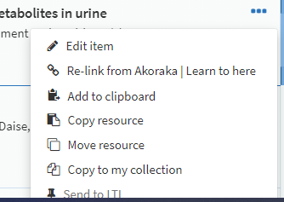

In Leganto

Adding a section
- Click new section at the top of the page
- Give the section a title (1) and click create (2)
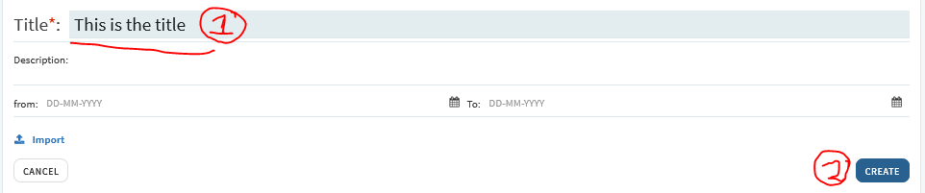

Short Loan requests
- Add the item to the reading list
- Click on the item in your reading list
- It will show as “Sent” – click on this
- In the top right, click “Discuss with LTL” and note whether you want it on 2hr or 24hr loan

Adding an item
- Click on
- Click
- Search for the item on the right side bar under ‘Search Library Resources’
If you find the item, and it states ‘Full text available’:
- Click on it and “Add” it to your reading list
- It will automatically complete (1) but you should click “View online” (2) to check the link is working:
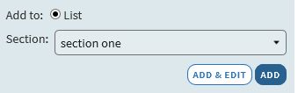 -> 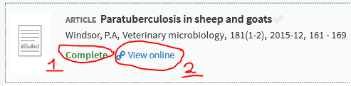

If you find it, and it states ‘No full text available’, but you have a file you can upload:
- Click on it and “Add & edit”
- Drag and drop or click to browse to upload your file
- Check details are complete (especially chapter/page numbers to speed up copyright clearance).
- Click “Add” to save. Next you’ll need to request copyright clearance – see below.
If you don’t find it:
- Click then click
- Drag and drop or click to browse to upload your file
- Check / choose the Type of resource (Book chapter, Journal article, etc.)
- Check / add all the details you have, especially title, author, date, publisher, chapter/page numbers to speed up copyright clearance.
- Click “Add” to save. Next you’ll need to request copyright clearance – see below.

Requesting copyright clearance:
- After you save the item it will show as “Being Prepared” or “Sent”.
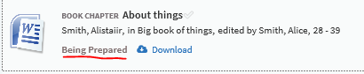
- Click on the item.
- On the detail screen scroll down to Requests and click to request copyright clearance from LTL.
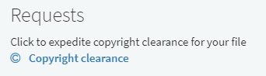
- Fill in either the chapter or the pages required
- If there’s enough information, the system may auto-approve it and it will be available immediately (showing as Complete). Otherwise LTL has to check it manually – this takes up to a week so submit your items early.

