Creating a Leganto reading list based on another course
This guide is for when you want to create a list for a course based on a reading list for a different course code (eg copying INFO103 -> DATA601) or a different semester (eg copying INFO103 S1 -> INFO123 S2).
If you want to re-use the list from the same course and same semester as last year, look for our instructions on Rollover.

Method 1: Creating the new list from scratch
This method is for when you don’t yet have any reading list for the new course – not even an empty one.
- Start by opening the reading list from the old course. In the “…” menu, select Export > To Leganto file and save to your computer.
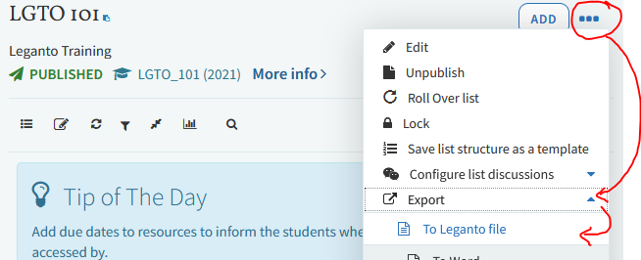
- Now go to the Akoraka | Learn page for your new course. Create a reading list link, click it, and on the next screen, click “Create it”.
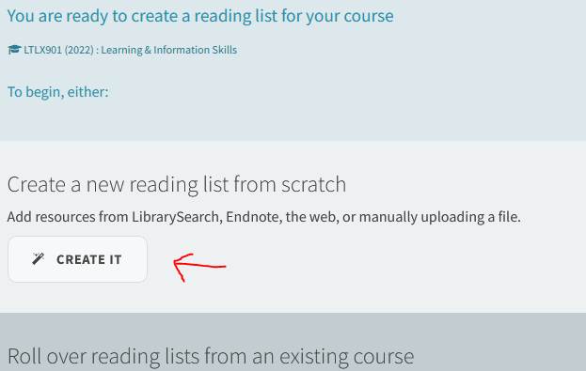
Note: if you see a Leganto reading list instead of getting these options, then stop here and switch to Method 2.

- Add the year into the title, and click the Import icon:
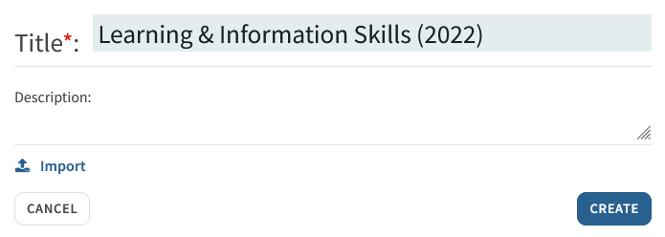
- Upload the export file you saved previously (if you didn’t rename it, it will be called legantoList.lgn) and click Create.
- On the new reading list:
  - Check the title is correct (sometimes this reverts to the title of the old reading list)
  - Publish the list
  - Click each item with a download file to request copyright clearance
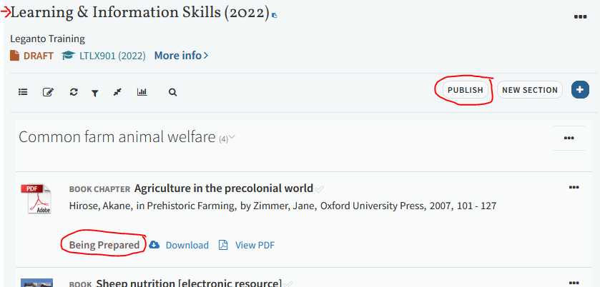

Method 2: Copying content from one list to another
This method is for when a reading list (even a blank one) already exists for the new course and you want to copy content from another list into it.
- Start by opening the reading list from the old course.
- For each section, working from top to bottom, click the section’s “…” menu and select “Copy section”.
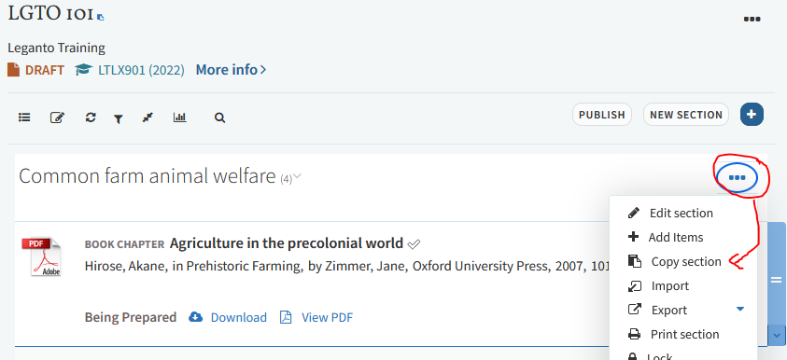
- Edit the new section name to remove “Copy of” and select the reading list you want to copy it into. Click Confirm.
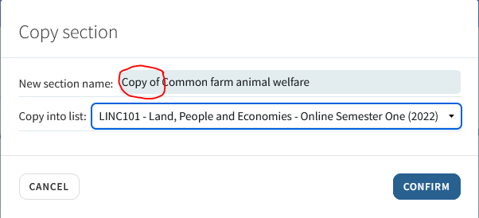
Note: if the list you want doesn’t appear in the list then stop here and switch to Method 1.
- Repeat for each of the sections you want to copy.
- When you’ve finished, go to the Akoraka|Learn page for the new course and open the reading list from there. All the new content should now appear in it. Now:
  - Publish the reading list
  - Click each item with a download file to request copyright clearance
