Creating a Leganto reading list based on items from Equella

Start in Akoraka | Learn
- Add an activity
- External tool
- Type in "Reading list" (or other name you want to give the link)
- Select Preconfigured Tool = Leganto, then Save
- Click on the link you created: it will take you to Leganto
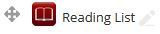

“Rollover” the migrated Equella content
In Leganto you’ll see your course code and name at the top, and options to either Create or Rollover.
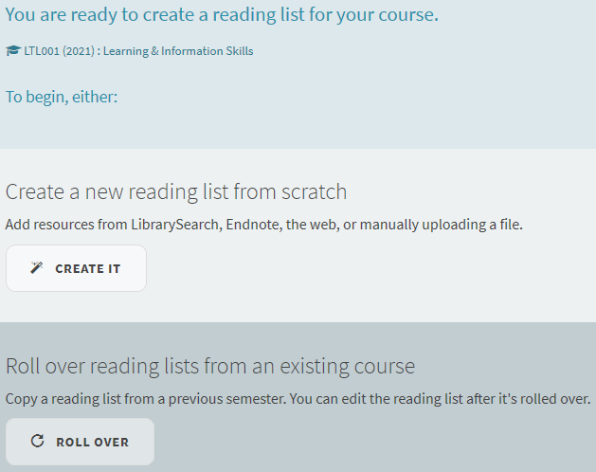
Click the Roll Over option, and type your course code in to select the correct option from the list.
Click Roll Over again to confirm.
You will now have a reading list containing items imported from Equella.
Note: If you don’t see the correct course code at the top of the page, or the course code doesn’t come up in the dropdown list, please contact LTL for troubleshooting.

Finish preparing your list
More instructions for these steps are found at https://ltl.lincoln.ac.nz/teaching/Leganto
Required steps (so that content is visible to students):
- Click the “Publish” button so students can access the list
- Click on each item you still want to use to open it up and request copyright clearance
Recommended steps (to make the list easier to use):
- Edit the reading list name to include the current year, eg “Learning & Information Skills (2022)
- Edit the “Imported from Equella” section name
- Add a section corresponding to each Learn module and move items into the appropriate section

