Adding web resources to your reading list
Of course if a web resource is freely accessible on the web, you can just link directly to it from Learn. But if you want to include it in your reading list, follow one of the methods below.

1. Create a record manually
This method might be a little quicker if you only rarely add websites to your reading list.
- In your Leganto reading list, click the button
- Use the option to an item
- Choose Type = Website
- Fill out as many of the details as you can (thinking of what your students need to cite it), especially the title and URL
- Click

2. Install and use the ‘Add to Leganto’ bookmarklet
This method will take longer to set up the first time, but adding items after that will be much quicker.
To install it the first time:
- If your browser is not already showing a bookmarks bar, follow the instructions for your browser at https://www.computerhope.com/issues/ch001917.htm
- In Leganto, click your initials in the top right corner, then click “Add to Leganto!”
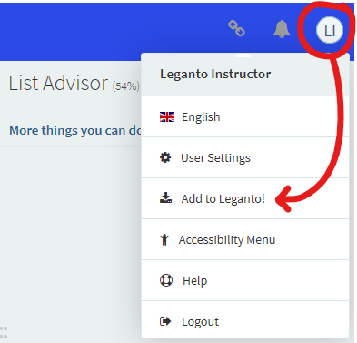
- Click-and-drag the button into your bookmarks bar

To use the Add to Leganto! Bookmarklet
- Go to a website
- Click the “Add to Leganto!” bookmarklet in your toolbar
  - If you’re prompted for your username and password, enter these. After you’ve logged in, close the tab. Now on the website you want to add, click the bookmarklet again.
- Check the item details are correct and complete enough for your students to use in a citation
- In the dropdowns at the bottom, select the reading list and the section you want to add it to.
- Click “Add & Close”

