# Rollover in Leganto

Before every semester, you need to rollover your reading list (and publish it) to make it available to your new class. The following screenshots take you through this process step by step.

1. From Akoraka | Learn, click on your old reading list link. Then in the “...” menu select “Roll Over list”:

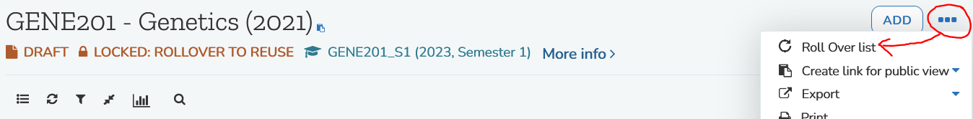

1. Click on “Look up course”, then from the pop-up menu that appears click the course code for this reading list.

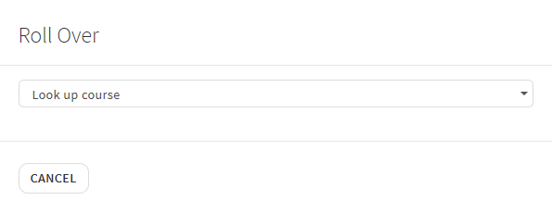

1. Check the Reading list name. The new year will be added at the end. If it still includes the previous year somewhere else, just delete it. Then click “Roll over”:  
   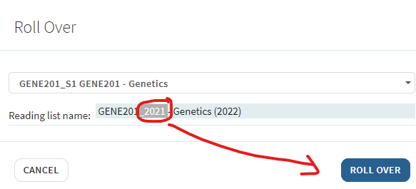
2. Click “OK”, then “Close”
3. A notice will remind you that you’re still on the old list. Click the link to go to the new list:  
   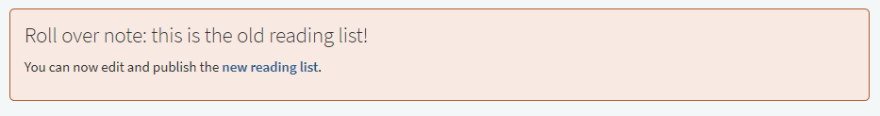
4. On the new list, **remember to click “Publish”** to make the list viewable by students!   
   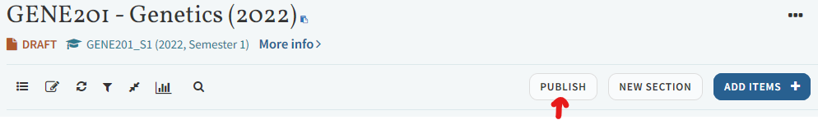

**Now:**

* All your existing Akoraka | Learn links will redirect to the new list. ☺
* All your copyright activations will be automatically re-processed (or re-submitted for manual LTL approval if needed). ☺ ☺ It’s still a good idea to check that these all show as “Complete” and look as expected when you “View list as student”.

## Note FYI:

Students clicking on the Learn link will go straight to the current list. But as lecturer you’ll be taken to a menu of past reading lists. The **current** list will be **on top** and should include the current year:

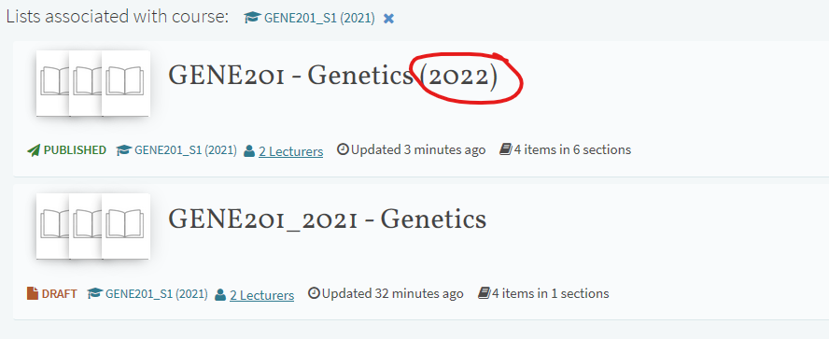

If you accidentally go to the old list, it will remind you with the Roll over note, and give you the link to the new one:

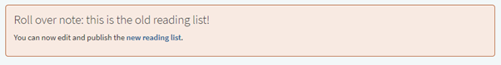

If links or lists get confused, please contact LTL for support!