Creating a reading list from scratch
This guide is for when you don’t have any previous content from Equella or Leganto.

Start in Akoraka | Learn
- Add an activity
- External tool
- Type in "Reading list" (or other name you want to give the link)
- Select Preconfigured Tool = Leganto, then Save
- Click on the link you created: it will take you to Leganto
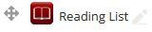

Create the Leganto list
You will be given the following options:
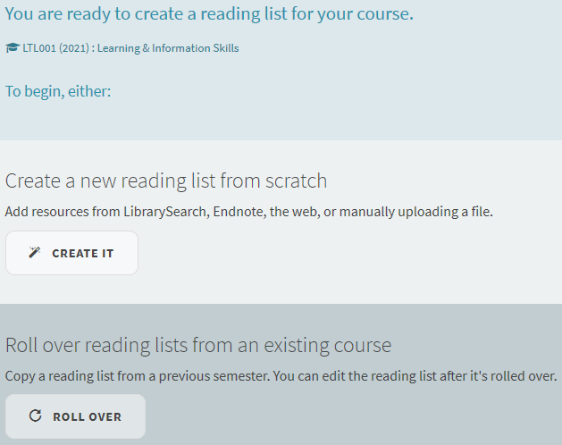
- Check that the correct course code and course name appear at the top of the screen. If not, contact LTL for troubleshooting.
- Click “Create it”
- Add the year into the title and click “Create”.
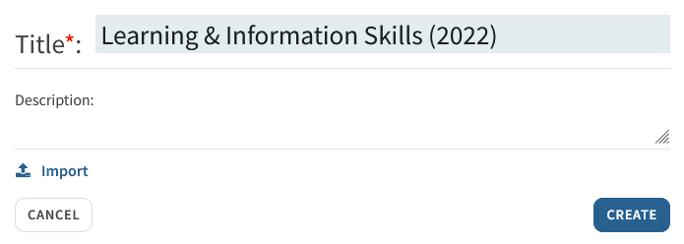
- Select whichever of the two template options you prefer. The Default template is completely empty and the Multiple Sections template has some empty sections created for you.
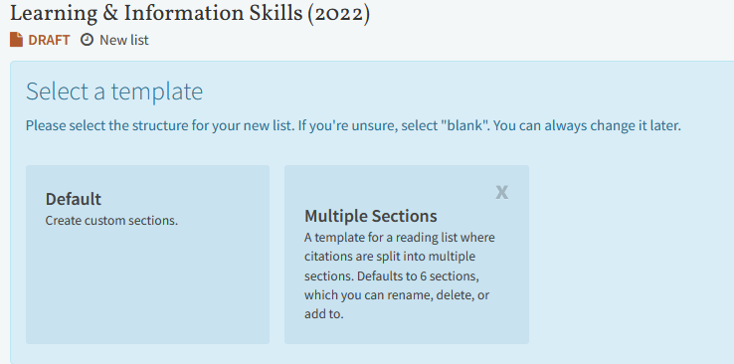

Publish and edit the reading list
You should now see your reading list.
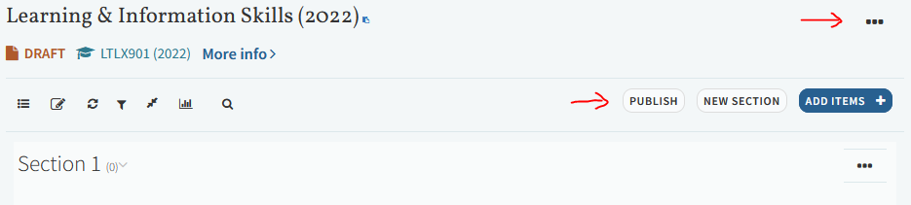
- Check the title is correct and includes the year (if not, click the “…” icon to the right to edit it).
- Publish the list so students can access it. The default is to be more open but you can change this if you want. (Only course students will be able to access the actual full-text.)
- Edit existing sections or create new ones, add items, etc. For more guides on these functions, see https://ltl.lincoln.ac.nz/teaching/leganto

